**Luray – Page County Chamber of Commerce**



18 Campbell Street, Luray, VA 22835 - Tel: 540-743-3915 - Fax: 540-743-3944

www.VisitLurayPage.com

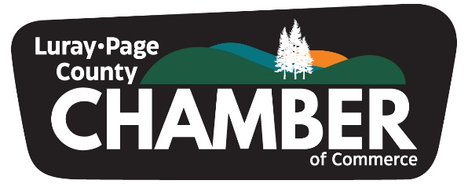

**For Immediate Release Contact: 540-743-3915**

**February 14, 2025** [**events@luraypage.com**](mailto:events@luraypage.com)

**Luray-Page County Chamber of Commerce Unveils New Brand Identity**

**Luray, VA –** The Luray-Page County Chamber of Commerce (LPCCC) is proud to introduce a fresh and dynamic brand identity, reinforcing its commitment to fostering growth, collaboration, and prosperity in the local business community. The rebranding initiative includes a newly refined Mission, Vision, Core Values, and Promise, all designed to guide the Chamber into an exciting new era of engagement and impact.

"This rebranding effort reflects our deep-rooted history while embracing the future with renewed clarity and purpose," said Regina Hilliard, President of the Luray-Page County Chamber of Commerce. "We are dedicated to creating meaningful opportunities for our members, strengthening connections within the community, and positioning Luray-Page County as a hub for business success."

**A Refreshed Mission and Vision for the Future**

The LPCCC’s updated Mission emphasizes its dedication to serving its members through collaboration, innovation, and unwavering commitment to supporting local businesses and the community. The Chamber’s Vision is to be a catalyst for a thriving, inclusive business environment innovation thrives, connections flourish, and opportunities are endless.

**Guided by Core Values**

LPCCC’s rebrand is built upon five key Core Values that define its role in the community:

**• Connection:** LPCCC is committed to offering member businesses valuable resources, networking opportunities and community relationships.

**• Collaboration:** LPCCC encourages and supports member collaboration that secures a relevant, active, and growing business community through mutually beneficial partnerships facilitated by common goals for overall economic sustainability.

**• Commitment:** LPCCC is a trusted, dependable and engaged resource for the business community.

**• Opportunity:** LPCCC provides educational and professional development outreach, training, and networking strategies that target business and owner empowerment for success.

**• Integrity:** LPCCC promotes a respected standard of conduct built on honest and transparent engagement with members, stakeholders and the community.

**A Promise of Inclusivity and Growth**

As part of its renewed commitment, the LPCCC reaffirms its Promise to foster an inclusive and diverse business environment, ensuring accessibility and representation for all individuals, regardless of background, identity, or economic standing.

**A Brand Rooted in Community**

The new brand identity incorporates visual elements that symbolize Luray-Page County’s strong foundation and future aspirations. The logo design reflects the area's natural beauty, heritage, and commitment to growth, with three trees representing the county’s three towns and a horizon that signifies new beginnings and opportunities.

With nearly a century of history dating back to 1926, the Luray-Page County Chamber of Commerce continues to be a cornerstone of the local business community. The rebranding aligns with its mission to provide businesses with the support and resources needed to thrive in an ever-evolving economic landscape.

For more information about the Luray-Page County Chamber of Commerce’s rebranding and initiatives, visit www.visitluraypage.com or contact the Chamber at (540) 743-3915.

**About the Luray-Page County Chamber of Commerce**

The Luray-Page County Chamber of Commerce serves as a vital resource for businesses in the region, fostering economic development, advocating for local businesses, and building a strong, connected community. Through collaboration, innovation, and leadership, the Chamber is dedicated to ensuring a prosperous future for Luray-Page County.