Staff  Gina Hilliard, President  Edison Emmons, Social Media & Marketing Assistant  Clancey Arnold, Membership Development &  Investment Administrator  Courtney Stoneberger, Chamber & Tourism Assistant  Board of Directors  Executive Officers:  Chris Jenkins, Chair  Faithbrooke Barn and Vineyards  Travis Clark, Vice-Chair  Valley Health Page Memorial Hospital  DezaRae Beers, Secretary  Yogi Bear's Jellystone Park  Miranda Cave, Treasurer  Blue Ridge Bank  Bill Huffman, Chair of the Tourism Division  Luray Caverns  Board Members:  Mitch Lovinger – Appexnetwork Physical Therapy  Amy Judd – Lord Fairfax Community College  Sable Ponn – Funkhouser Real Estate Group  Pam Wightman – Delaware North at SNP  Bart Patton - Patton Gunsmith Works  David Thomas - Valley Star Farm  Mark Dofflemyer – Pioneer Bank  Tony Villa – Madeline Farms  Follow Us on Social Media  Facebook  LurayPageCountyChamber  VisitLurayPageVA  Instagram  LurayPageCountyChamber  VisitLurayPageVA  Twitter  VisitLurayPage  You Tube  LurayPageCountyChamber  VisitLurayPageVA | Ambassadors  Clancey Arnold, Chair – Luray-Page County Chamber of Commerce  Sable Ponn, Vice-Chair – Sable Ponn, Funkhouser Real Estate Group  Amanda Petty – Amanda Petty Homes with Re/Max Gateway  Zory Glaser – Cardinal Cottage Vacation Cabin Rental  Nancy Boyer – Page County Public Forum  Christine Caldwell – Studio 31.13  Tourism Council  Restaurants:  Helen Morton – Delaware North  Romeo Pugliese - Mamma Mia Italian Restaurant  Lodging:  Nancy Sottosanti, Treasurer – Shenandoah River Outfitters  DezaRae Beer – Yogi Bear Jellystone Park  Jim Sims – The Mimslyn Inn  Attractions:  Bill Schumacher, Vice-Chair – Fort Valley Ranch  Bill Huffman, Chair – Luray Caverns  Services:  Chris Jenkins – Faithbrooke Barn and Vineyards  CeCe Castle, Secretary – Brookside Restaurant
 | 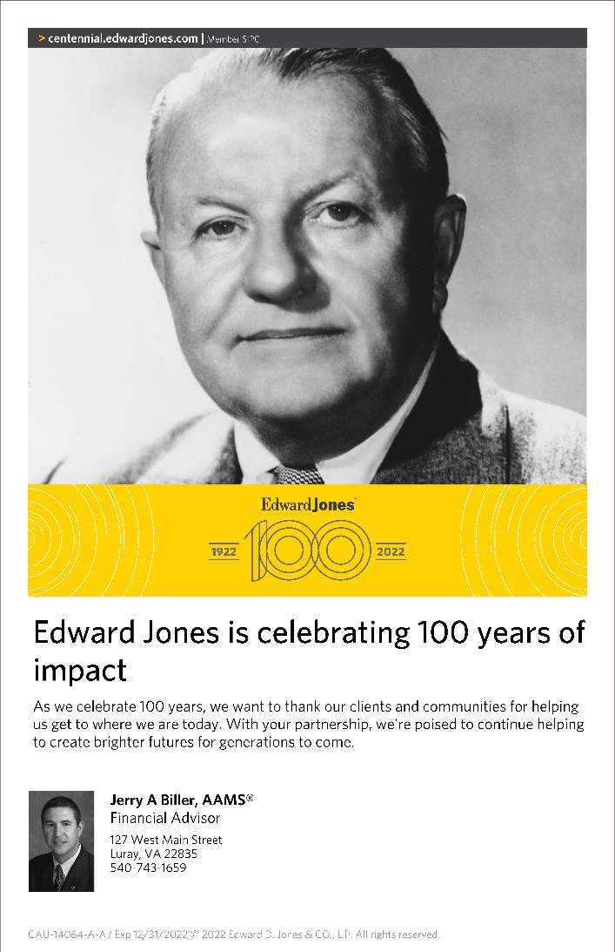

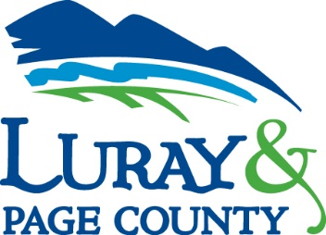
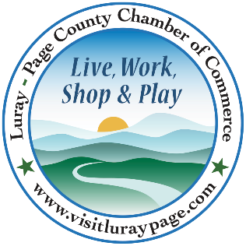

Luray-Page County Chamber of Commerce & Visitor Center
18 Campbell Street, Luray, VA 22835
Phone: (540) 743-3915 • Fax: (540) 743-3944
www.visitluraypage.com

June 2022 Newsletter

The Luray-Page County Chamber of Commerce's mission is to serve our members by promoting and supporting business and tourism throughout Page County. The Luray-Page County Chamber of Commerce's vision is to be the organization where our business community turns for leadership and resources.

Chamber Events

Thursday, June 2nd, 5:30 PM
96th Annual Banquet & Awards – Off to the Races
96th Annual Banquet & Awards: Off to the Races. A Kentucky Derby themed celebration of the Luray-Page County Chamber of Commerce 96th year in the Page County business community. The Annual Banquet & Awards will be held at River's Bend Ranch, 397 Rivers Bend Road, Stanley, with a cocktail hour, silent auction, catered meal, and awards. We’re excited to share this time of celebration with all of our amazing members. Tickets will be $75.00. We will share plenty of photos afterward. For more information on the 96th Annual Banquet & Awards visit our website at:
https://www.visitluraypage.com/chamber/chamber-events/annual-banquet-business-meeting/

Wednesday, June 8th, 12:00-12:30 PM
Valley Business Today – Gardening in the Valley
Lesley Mack, owner of Birdsong Pleasure Garden, is joining Edison Emmons to share information on The Northern Shenandoah Valley Master Gardener Association’s Gardening in the Valley Garden Tour. Listen in to The River 95.3 or https://theriver953.com/podcasts/the-valley-today/ to learn about this year’s Garden Tours. To be a future guest on the Tourism Tuesday Radio Show, contact Edison at edison.emmons@luraypage.com.

Thursday, June 9th, 2:00-3:00 PM
Business Seminar - Instagram
Join us on the Zoom screen from 2pm – 3pm on Thursday, June 9, 2022, for a free webinar to learn "5 Little Instagram Things" that could make a big impact. A lot has changed with Instagram since it came on the scene in 2010 - but some things haven't. In this webinar, Janet Michael from Java Media will explain 5 little things you should start, change, or stop to get the most marketing juice out of your Instagram presence. Attendance is free but registration is REQUIRED. Register here: https://bit.ly/5IGthings. Janet Michael is the owner of Java Media, a social media and marketing firm, with over 20 years of experience developing successful marketing & advertising campaigns. Java Media provides social media training and workshops for small business owners as well as social media management, oversight & evaluation services. She produces podcasts for small business owners, non-profits, and local leaders. Janet also hosts a daily award-winning talk show, The Valley Today, on local radio station, The River 95.3FM.

Wednesday, June 15th, 12:00-1:00 PM
Small Business Growth – More Sales & More Customers: The Good, the Bad, and the Ugly
Join us for Small Business Growth interactive workshop series in partnership with Shenandoah Valley Small Business Development Center (SDCD) via zoom. Whether you are just starting out or have years of experience, these discussions will challenge your way of thinking and help you avoid common pitfalls as you grow your business. We’ll be discussing Who doesn’t want higher sales and more customers? Let’s just make sure More = Good for you and your company. Plus, you’ll leave with a confidential self-assessment to help you identify your specific challenges and most important needs. All workshops are free of charge. RSVP to events@luraypage.com or 540-743-3915 by Monday, June 13th, to receive the Zoom link plus session materials.

Thursday, June 16th, 5:30-7:00 PM
Business After Hours – Town of Shenandoah Museum
Join us on Thursday, June 16th, from 5:30-7:00 PM, for Business After Hours at Town of Shenandoah Museum, 507 First Street, Shenandoah. Our host, Town of Shenandoah, and co-host Shenandoah Industrial Corporation will be providing a great networking opportunity, tasty refreshments provided by the Shenandoah Heritage Center, and some great door prizes. Tonight’s Business After Hours is the perfect chance to get a sneak peak of the new Town of Shenandoah Museum before it officially opens on June 18th, where they have history of the town, as well as pretty neat train exhibit. This event is designed for Chamber members to meet and build relationships with other local business members. It is time to get together and enjoy each other’s company. You will have the opportunity to introduce yourself to other members, exchange business cards, make new business contacts, win door prizes, and enjoy refreshments.

Saturday, June 18th, 12:00 PM
Town of Shenandoah Museum Grand Opening & Ribbon Cutting
Join us on Saturday, June 18th, at 12:00 PM, to celebrate the grand opening of the Town of Shenandoah Museum. The museum is located at 507 First Street, Shenandoah and will feature a model railroad and history of the town. We’ll be cutting the ribbon at 12:00 PM to kick off the celebration. After the ribbon is cut, stick around and enjoy the festivities until 4:00 PM.

Tuesday, June 21st, 12:00-12:30 PM
Tourism Tuesday – Town of Stanley
Terry Pettit, town manager for the Town of Stanley, is joining Edison Emmons to share information on their 55th Annual Homecoming. Listen in to The River 95.3 or https://theriver953.com/podcasts/the-valley-today/ to learn about Stanley’s Annual Homecoming Festival. To be a future guest on the Tourism Tuesday Radio Show, contact Edison at edison.emmons@luraypage.com.

Tuesday, June 28th, 11:30 AM-1:00 PM
Women in Business Lunch – Communication: The Key to Getting Results
Join us at The Valley Cork, 55 East Main Street for this month’s Women in Business Lunch. Our guest speaker will be Jay Foreman, 2nd Story Communications, and his presentation will be on communication: The Key to Getting Results which will include ways to discover your "why" and develop personal communication strategies that emphasize empathy. Jay Foreman is a John Maxwell certified Leadership trainer. He has a master’s degree in Executive Leadership and over a decade of experience presenting to businesses, non-profits, schools, and churches. Jay brings to the table a combination of business experience and applicable real-world leadership knowledge. Jay is an award-winning, best-selling author as well as a certified virtual presenter. He has been featured on television, radio, newspaper, and magazines. More information can be found at jaywforeman.com.
Lunch will be provided by the Valley Cork and will cost $15 for Chamber Members and $20 for Potential Members. Thank you to Andersen Corporation for sponsoring this year’s Women in Business events. If you are interested in attending, please RSVP to events@luraypage.com or 540-743-3915 by Friday, June 24th.
Women in Business aims to provide resources and engagement for personal and professional development among entrepreneurial women, offer a space of fellowship and networking among peers, and support the next generation of young entrepreneurs in, and around, Page County. This event provides the opportunity to meet other professional women and form deeper connections within the community. We welcome women entrepreneurs, executives, and professionals of all levels eager to network and create connections. This diverse community of women is dedicated to helping and supporting one another as they address the barriers that women in business can face. This is the perfect chance for the women of the Page County business community to get together, enjoy a delicious lunch, and learn about ways to succeed.

New Member Spotlight
The Mountains Are Calling, LLC
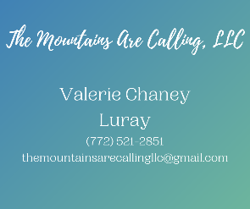
The Mountains are Calling, LLC, Luray, is a new transportation business that offers guided van trips through the Shenandoah National Park and Harpers Ferry National Historical Park. Val Chaney, owner and operator of The Mountains are Calling, grew up in West Virginia, where the love of the rolling hills and farmland led her to a career with both the National Park Service and West Virginia State Parks. After getting her foot in the door, Val had the opportunity to work in National Parks all over the country. A current resident of Berkeley Springs, WV, Val works full time as a Park Naturalist at Cacapon Resort State Park. Her love of the National Park System, especially the Shenandoah National Park and Harpers Ferry National Historical Park encouraged her to start The Mountains are Calling. On Sundays and Mondays, she offers day excursions by van through the Shenandoah National Park, as well as private group tours to Harpers Ferry NHP.
For more information on their services and tours, visit https://www.themountainsarecallingllc.com/, email themountainsarecallingllc@gmail.com, or call (772) 521-2851.

Member Spotlight
Hawksbill Brewing Company
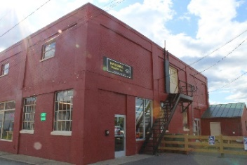
Hawksbill Brewing Co., 22 Zerkel Street, Luray, is a local brewery in downtown Luray. Owned by Jim Turner, Hawksbill Brewing is Luray-Page County’s only brewery and offers a variety of freshly brewed beer choices. Hawksbill Brewing opened their doors in May 2017 and have been serving fresh brews to their patrons since. With a goal to bring people in our community together over beer, they offer both indoor and outdoor seating options. Their ever-changing tap list is filled beers that are made from as many local products as possible. Now, going into their 5th year of business, HBC is continually working on new brews and finding new ways to bring people in our community together.
To learn more, visit https://hawksbillbrewing.com, email hawksbillhops@gmail.com, or give them a call at (540) 860-5608.

Chamber Announcements

Any advertising inserted and printed in this newsletter and the content of those inserts and print ads are not sponsored or endorsed by the Luray-Page County Chamber of Commerce & Visitor Center.

If you have a business in mind that you think would benefit from a Chamber membership, make sure to refer them to us. If a new member signs up and mentions your business as who referred them, you’ll receive $50 of your next set of membership dues.

To keep up with everything going on at the Chamber, make sure to follow our Social Media Accounts. Here you’ll find information on events, what’s going on in the community, and information on our members.

If you have events happening, please send them to Edison at edison.emmons@luraypage.com. We will put all member events on our Community Calendar, as well as promoting them on our social media pages.

Our weekly In the Loop emails aren’t just for the primary representative in your business. Any employee within your business can receive our weekly e-newsletter. If you have employees that would like to receive these weekly e-newsletter, send their information to Edie.

